Bryan Guner

Water Brief

"Solutions to Water Crisis." *Africa Needs Community Development Corporation Inc RSS*. Africa Needs, n.d. Web. 12 Nov. 2014.

* One solution to the water crisis in Ethiopia is to integrate solar powered water wells.
* It’s eco friendly and environmentally safe
* Saves (primarily women) from the large amounts of time required to pump water.
* The system pumps water out of a water source, purifies it and sends it to the local village.
* Effectively creates running water in areas without the infrastructure.
* Does not require the human labor of traditional merry go round pumps
* 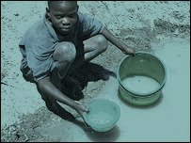

*(this source highlights a potential solution to the time constraints of collecting water that often prevent the matriarch of a family from providing her children with better opportunities)*

"LifeStraw... It's Life." *LifeStraw.org.uk*. Life Straw, n.d. Web. 12 Nov. 2014.

* Life straw is a personal portable water purifier for the prevention of diarrheal disease.
* It’s 25cm long and 29mm in diameter.
* There is a family sized gravity powered bucket-life straw that can filter 18,000 liters of water, enough to supply a family of five with water for three years.
* Points of technical performance are (“Complies with US Environmental Protection Agency 1987 Guide Standard and Protocol for Testing Microbiological Water Purifiers:
  + Removes minimum 99.9999% of bacteria (>LOG 6 reduction)*
  + Removes minimum 99.99% of viruses (>LOG 4 reduction)*
  + Removes minimum 99.9% of protozoan parasites (>LOG 3 reduction)*
* Removes turbidity
* Requires no electrical power, batteries or replacement parts
* Requires no running water or piped-in water supply
* Has an easy-to-clean prefilter and purification cartridge
* All raw materials are US Food and Drug Administration compliant or equivalent”)

*(the life straw is already a working solution that is saving lives and improving the quality of life at the same time as turning an entrepreneurial profit.)*

Vorosmarty, Charles, Pamela Green, Joseph Sailsbury, and Richard Lammers. "Global Water Resources: Vulnerability from Climate Change and Population Growth." *Science Magazine: Sign In*. Science, 14 July 2000. Web. 09 Oct. 2014.

* Assessments of water venerability often occur on a country wide or regional basis which inaccurately depicts the conditions of water availability.
* (RWD) is the ratio of water use to discharge
* (DIA/Q) is an amalgamation of industrial, domestic and agricultural water use in relation to the amount of available water.
* (DIA/Q) is a ratio that determines the degree to which humans interact with sustainable water supplies and acts as an index of water stress.
* Index of .2 to .4 indicate medium water stress, values above .4 denote high water stress.

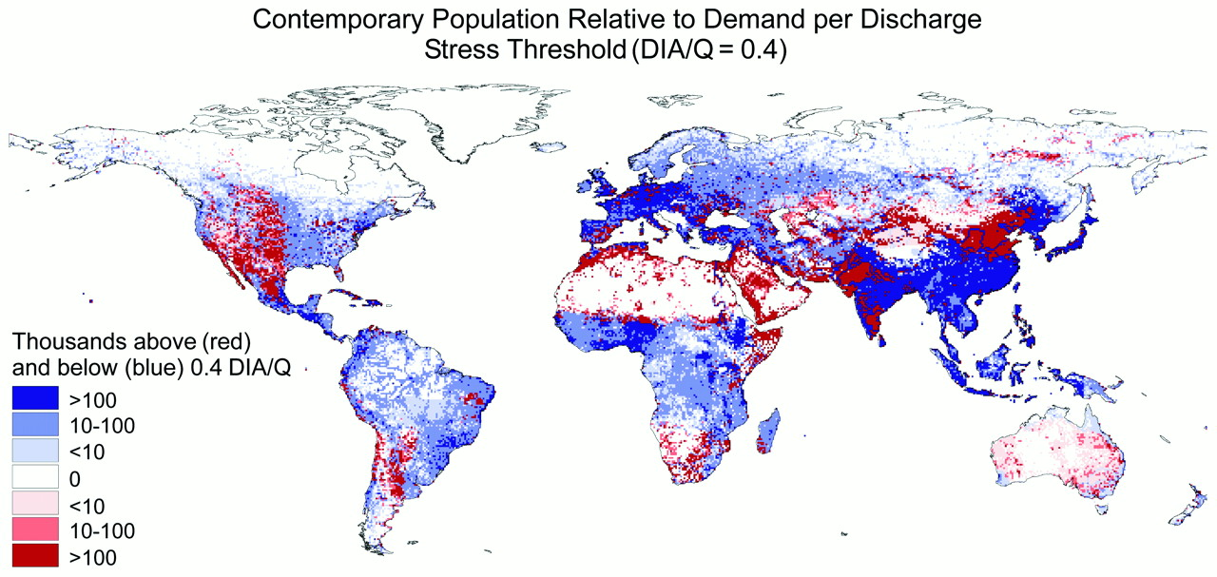

The global distribution of population in 1985 with respect to the relative water stress threshold of DIA/Q = 0.4 indicating severe water scarcity (10). A 30′ spatial resolution is used. This mapping reflects a mean global runoff of ∼40,000 km3year−1 and aggregate water withdrawals of 3100 km3 year−1. These estimates are highly dependent on contemporary water use statistics, which reflect a degree of uncertainty. Recent reviews (5, 36) show year 2000 global water withdrawals from assessments made even as late as 1987 to vary by >1300 km3year−1. National-level water use statistics (18) for some countries are decades old. Runoff estimates for some regions may also be biased (9,13). Results should be viewed with appropriate caution.

* Based on the figure above we find that the main cause of change in (RWD) and therefore venerability to water stress is growth and economic development of humans.
* More than 3 billion people are supported by irrigated agriculture ( a major source of water stress)

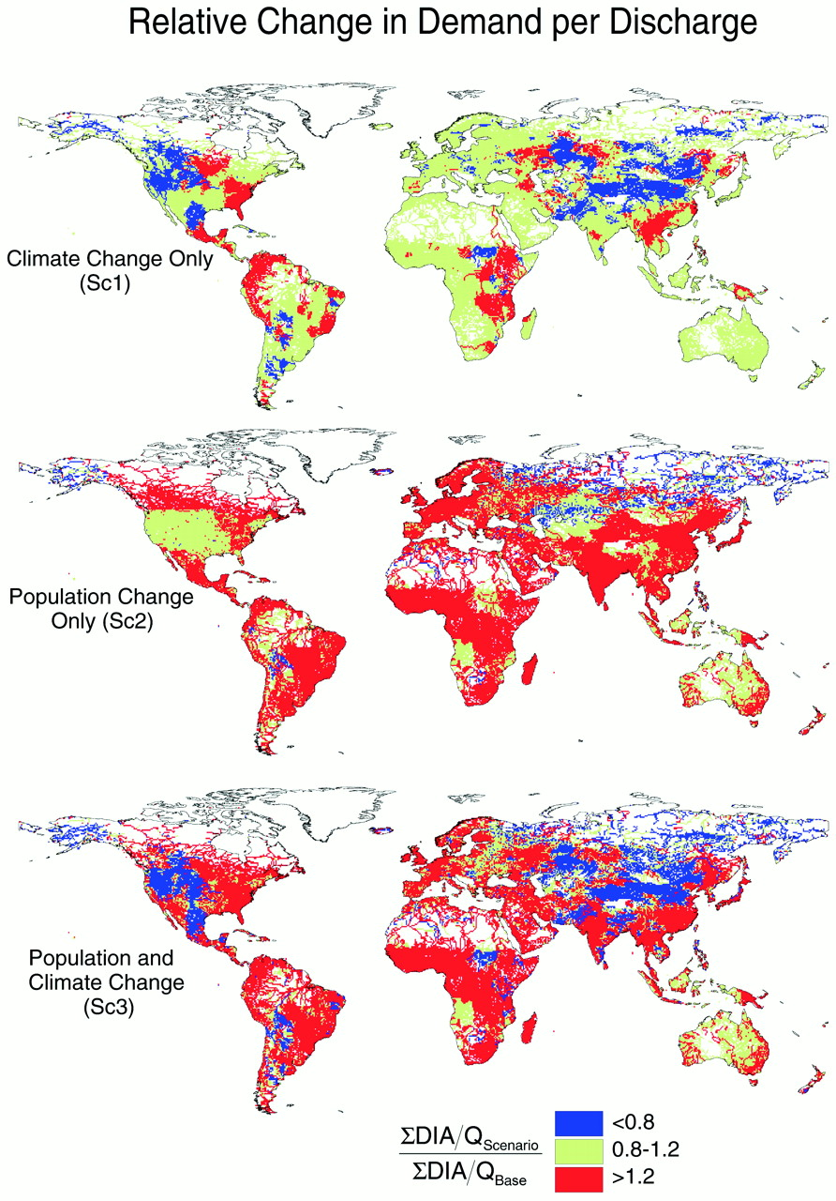

**Maps of the change in water reuse index (ΣDIA/Q) predicted by the CGCM1/WBM model configuration under Sc1 (climate change alone), Sc2 (population and economic development only), and Sc3 (both effects). Changes in the ratio of scenario-specific ΣDIA/Q(ΣDIA/Q Scenario) relative to contemporary (ΣDIA/Q Base) conditions are shown. A threshold of ±20% is used to highlight areas of substantial change.**

* If the projections on the above map prove to be correct than most of the world will soon face substantial challenges to provide it’s self with sustainable water.
* This increase in demand for water could potentially have economic impacts, a reduction in water quality and also potentially cause mass migration.
* Most of the world’s increase in population will occur in urban areas where citizens and governments will have to cope with increased water pollution and waterborne disease.

“We conclude that impending global-scale changes in population and economic development over the next 25 years will dictate the future relation between water supply and demand to a much greater degree than will changes in mean climate. To secure a more complete picture of future water vulnerabilities, it will be necessary to consider interactions among climate change and variability, land surface and groundwater hydrology, water engineering, and human systems, including societal adaptations to water scarcity [see (30, 31)]. Pursuit of this question will be limited by outdated and nonexistent socioeconomic data and information from a progressively deteriorating global network of hydrometric monitoring stations (32) unless a vigorous commitment is made by the water sciences community to collect, standardize, and widely disseminate such information. In light of our findings, an integrated approach bringing together the climate change, water resources, and socioeconomic communities appears essential to future progress.”

(*This source made it abundantly clear that water scarcity is very likely to increase over the coming years. It stressed the importance of both preemptive political action, and the need for innovative solutions to water scarcity and sanitization in order for a sustainable population.)*

Sullivan, Caroline. "Download PDFs." *Calculating a Water Poverty Index*. Science Direct, 19 Apr. 2002. Web. 10 Oct. 2014.

* Human behavior has an impact on water and the global ecosystem.
* We need to regulate that behavior in order to stabilize our future.
* Where there is “water poverty” any measure to reduce income poverty is likely to fail.
* Effective accounting processes must be applied to “ natural capital” rather than just financial equity because usable water is a finite quantity at any given time.
* While some work has been done to design auditing systems for water , systems to account for water usage are still underdeveloped at both the micro and macro level.
* In some areas, as much as 25% of women’s productive time is spent on water collection.
* This represents a significant cost to household human capital.
* Developing a comprehensive water development index would be a holistic policy tool drawing on both physical and social sciences in order to make better informed decisions regarding water policy.
* Developing such an index would allow policy makers to address crosscutting issues by integrating physical, social and economic markers into one cohesive measurement.
* While in theory this index is a no brainer , developing an accurate measure will prove challenging due to the complexity of the variables.

Table 2.

Distribution by sector of annual water withdrawals, selected states (%)

|  |  |  |  |
| --- | --- | --- | --- |
| Country | Domestic | Industry | Agriculture (irrigated and rainfed) |
| Egypt | 7 | 5 | 88 |
| Syria | 7 | 10 | 83 |
| UAE | 11 | 9 | 80 |
| Jordan | 29 | 6 | 65 |
| Saudi Arabia | 45 | 8 | 47 |
| WORLD | 8 | 23 | 69 |

“The complexity of the problem of water resource allocation can be illustrated by looking more closely at three countries in this region. For example, in Jordan, rapid industrialization and population growth has led to water demand being on the verge of exceeding water availability, and the high concentration of population around the capital city of Amman, has led to a significant rise in demand for domestic water (Allan & Karshenas, 1995), and in pumping water from regions hundreds of kilometers away. In Qatar, the almost total lack of rainfall means that agricultural development can be achieved only through the use of groundwater, and it is now known that the aquifer from which this is pumped, is likely to be depleted within 20–30 years. In addition, this groundwater is becoming heavily polluted by nitrates resulting from rapid urbanization and agricultural development (UNEP, 1987). Other typical pollution problems are demonstrated by the case of Syria, where inadequate sanitation and dumping of industrial wastes has led to significant ecological disruption in the Euphrates, Oronte and Barrada catchments (Biswas, 1994; Shuval, 1994). National water management problems are further confounded by overpumping of groundwater, giving rise to saltwater intrusion on the coastal plain. These and other issues highlight the importance of considering both ground and surface water when addressing the problem of water resource assessment, and in the development of the Water Poverty Index.”

* These patterns are seen throughout most countries.
* Solutions such as : more efficient irrigation, sustainable farming (avoiding water thirsty crops), curbing dependence on ground water, better resource accounting—must be implemented in conjunction with increased public awareness.
* As much as half of the world lacks readily available access to sanitized water.
* In order to link poverty to water resources (in order to understand how they affect each other) approaches such as including the poverty line, Headcount index, and poverty gap in the water poverty index must be perused. “The Poverty Line is a consumption-based measure comprised of an element representing the minimum level of expenditure required for basic necessities, plus an extra amount for that required to participate in the everyday life of society. This varies considerably throughout the world, but for developing countries it is thought to range from $275 to $370 per capita per annum. This measure indicates that over one billion people fall below the poverty line, roughly one-third of the total population of developing countries. The Headcount Index expresses the number of poor, as defined by the poverty line, as a percentage of the total population. In a large country like China, a relatively low Headcount Index can actually mean very large number of people. The Poverty Gap is sometimes called the Average Income Shortfall, an assessment of the amount of money that would be necessary to bring every poor person up to the poverty line. This is expressed as the aggregate income shortfall of the poor, as a percentage of aggregate consumption.”
* On top of the human needs for clean water the needs of the environment we live in must be accounted for as well.
* Numerous cases exist where ecological disruption has occurred as a result of human agricultural or industrial production.
* These oversights have occurred due to general indifference and a lack of knowledge of the complexities of the ecosystem.

“In areas where water shortages already exist, this situation has sometimes been presented as a conflict between water for people and water for nature. This ignores the fact that the global ecosystem provides our life-support system, and as such, its integrity needs to be maintained, not merely for ecocentric reasons, but equally for anthropocentric ones, as it is the direct and indirect benefits of functioning ecosystems which maintain human life-support systems.”

(*This article is multifaceted, it first addresses the need for tracking, accounting and allocating water resources as the first step. It then describes the development of an integrated water poverty index as a diagnostic policy tool and finally establishes the need and importance of water resources and solutions to preserve them.)*

Waititu, Earnest. "Africa's Growing Water Crisis." *PBS*. org, n.d. Web. 09 Oct. 2014.

* In Ethiopia deep wells that serve as the only source of water in an increasingly hostile environment are drying up.
* Annual rainfall is falling and even springs are drying out.
* Now a days it sometimes takes wells of up to 100ft to find water.
* Some tribes lost as much as 80% of their live stalk to dehydration last year.
* Strained resources have increased tensions between communities that are now competing for the same resources.
* In june 2006, The Borena and Guji people fought over Borena’s land killing hundreds and displacing 23,000 all over water resources.
* In 2007 the Intergovernmental panel on climate change forecast that Africa was at greatest risk for global warming and water poverty.

“Although Africa, of all the major world regions, has contributed the least to potential climate change because of its low per capita fossil energy use and hence low greenhouse gas emissions, it is the most vulnerable continent to climate change because widespread poverty limits capabilities to adapt.”

* Half of 314 million Africans that live on less than $1.00 usd per day rely on live stalk for their income and 80% of those people live on drying pastoral land.

*( This source contained first hand accounts of the real life effects of water poverty which were supplemented with relevant statistics.)*

"Water Wars." *Pulitzer Center on Crisis Reporting*. Pulitzer Center.org, 12 Jan. 2008. Web. 10 Oct. 2014.

* While global warming is mostly attributed to industrialized nations, it is often developing nations that feel it’s effects most heavily.
* Colonial era treaties granting water rights from the Nile to Egypt are leaving Ethiopian farms without access to irrigation.
* As droughts continue tribal disputes have been breaking out and have been intensified by Somalia arms trade.
* The burden of securing daily water supply has become a daunting task for women and young children who often spend hours per day transporting water.

(*This news article reveals the violent nature of water disputes in countries that do not have access to water infrastructure and adequate sources.)*

Lewis, Lori. "Water In Crisis - Spotlight Africa: Rural and Urban Issues." *The Water Project.org*. The Water Project, n.d. Web. 09 Oct. 2014.

* According to the WHO in 2006, only 59% of the world’s population had access to adequate sanitation.
* We will fall approximately 1 billion people short of the 2015 millennial goal to ensure 75% of people had access to clean water.
* Only 16% of Africa has access to tap water.
* Even when water is available the risks still include: poor maintenance of sanitation infrastructure, water Bourne pathogens and diseases such as malaria and Cholera, diarrheal disease.
* In urban settings the influx of water and human waste has outpaced water waste management facilities leading to high pollution in natural bodies of water.
* Over crowding in slums makes it even more difficult to control sanitization and disease outbreaks caused by exposure to raw sewage.

*(this source provided a general overview on the risks associated with poor water sanitization in both rural and urban impoverished regions.)*

Sengupta, Somini. "In Teeming India, Water Crisis Means Dry Pipes and Foul Sludge." *The New York Times*. The New York Times, 28 Sept. 2006. Web. 10 Oct. 2014.

* In India even in the richest areas the middle class often find that their plumbing is devoid of water and have to devote vast amounts of time and resources into procuring it on a daily basis.
* As a result of fast population growth, urban sprawl and a vast farm belt, water is very scarce in India and extremely contaminated in others.
* India’s economic prosperity is a direct result of it’s access to clean water.
* 2/3 of India does not have access to proper water sanitization.
* Not only does India struggle to get water, it struggles to get rid of waste.
* In New Delhi, 45% of the population is not connected to public sewage.
* The lack of unclean water kills approximately 2.1 million children under 5 per year in India.

“In Hindu mythology, the Yamuna is considered to be a river that fell from heaven to earth. Today, it is a foul portrait of crippled infrastructure — and yet, still worshiped. From the bridges that soar across the river, the faithful toss coins and sweets, lovingly wrapped in plastic. They scatter the ashes of their dead.In New Delhi the Yamuna itself is clinically dead.As the Yamuna enters the capital, still relatively clean from its 246-mile descent from atop the Himalayas, the city’s public water agency, the New Delhi Jal Board, extracts 229 million gallons every day from the river, its largest single source of drinking water.As the Yamuna leaves the city, it becomes the principal drain for New Delhi’s waste. Residents pour 950 million gallons of sewage into the river each day.Coursing through the capital, the river becomes a noxious black thread. Clumps of raw sewage float on top. Methane gas gurgles on the surface.”

*(this source provides graphic descriptions of the living/sewage conditions that plague most of Urban India. It describes the struggle that transcends poverty in areas where water is scarce and population is dense.)*